ACSM CEC Certificate

_______________________________________________________
Participant Name

Wheat Foods Council
________________________________________
Organization

Carbohydrates, Performance, and Weight Loss: Is Low
the Way to Go or the Way to Bonk?
_______________________________________________________
Course Title

792731 ____________________________________________1_________________
Approved Provider Number CECs Awarded Date

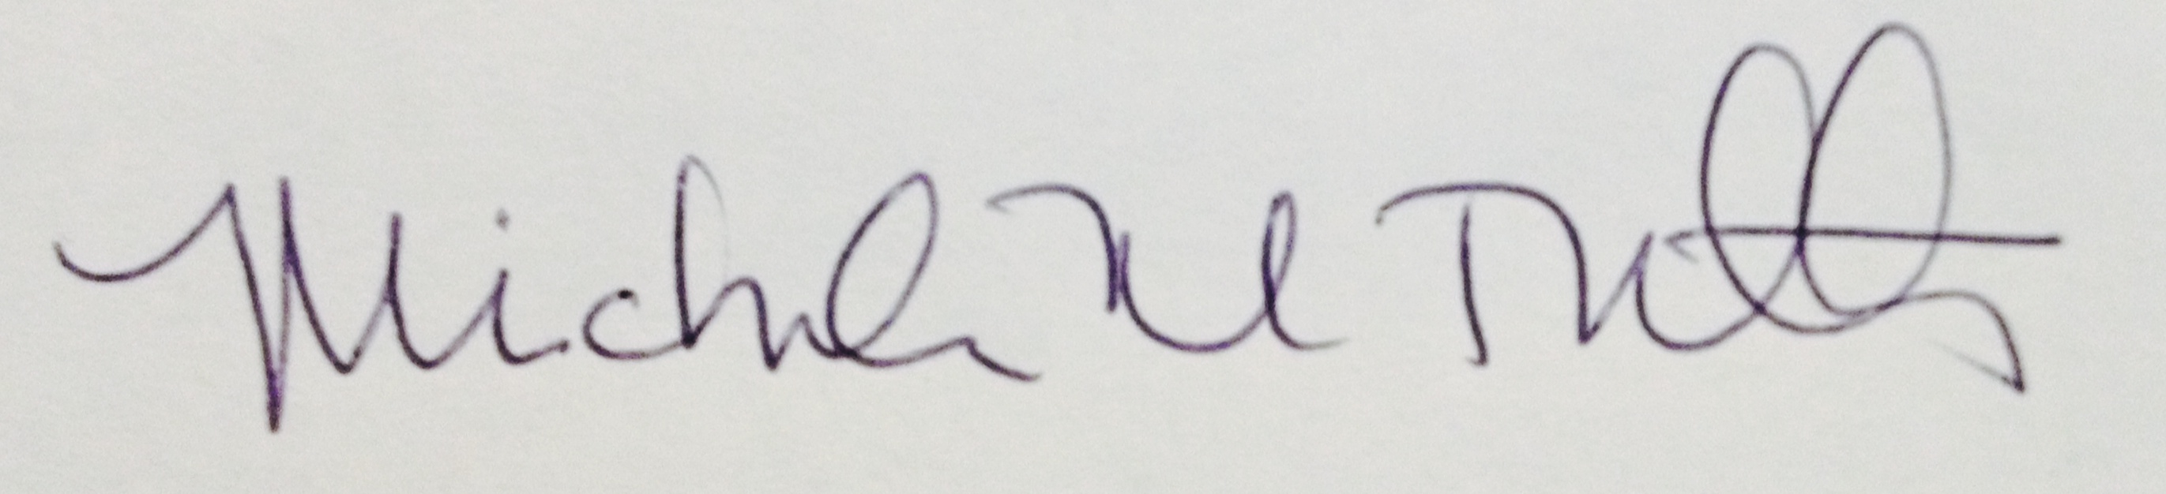
Lead Program Administrator Signature

